Chapter 9, Problem 90.

An industrial coil is modeled as a series combination of an inductance L and resistance R, as shown in Fig. 9.90. Since an ac voltmeter measures only the
magnitude of a sinusoid, the following measurements are taken at 60 Hz when
the circuit operates in the steady state:

Use these measurements to determine the values of L and R.
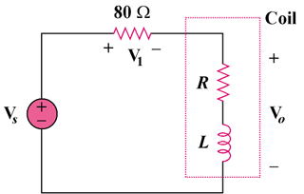

Figure 9.90
For Prob. 9.90.

